**Welcome to Independence Blue Cross**

**There are two ways to choose or change your PCP:**

**Online:** To select or change your doctor, visit www.ibxpress.com, our simple, convenient,

and secure member website. Click on the Change my Primary Care Physician link under the Find a Doctor or Hospital section.

**Phone**: Call 1-800-ASK-BLUE (TTY: 711) and one of our Customer Service associates will take your PCP selection over the phone

**IF YOU ARE ON THIS PART OF THE ENROLLMENT: *Keystone Health Plan East Direct POS coverage REQUIRES A PCP***

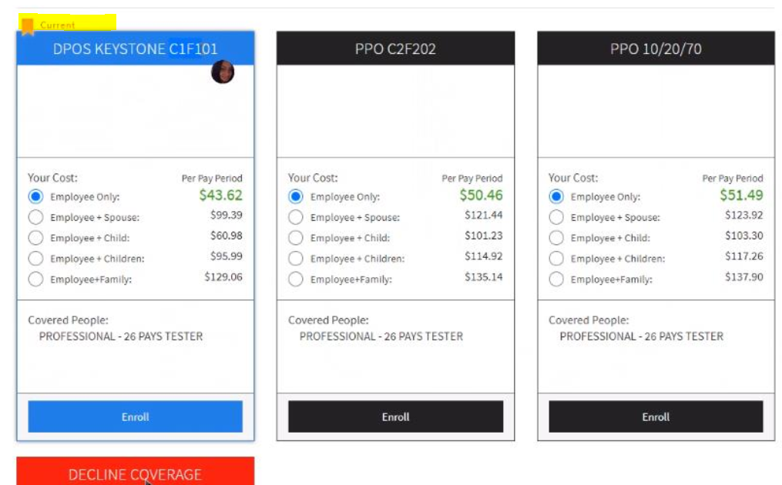

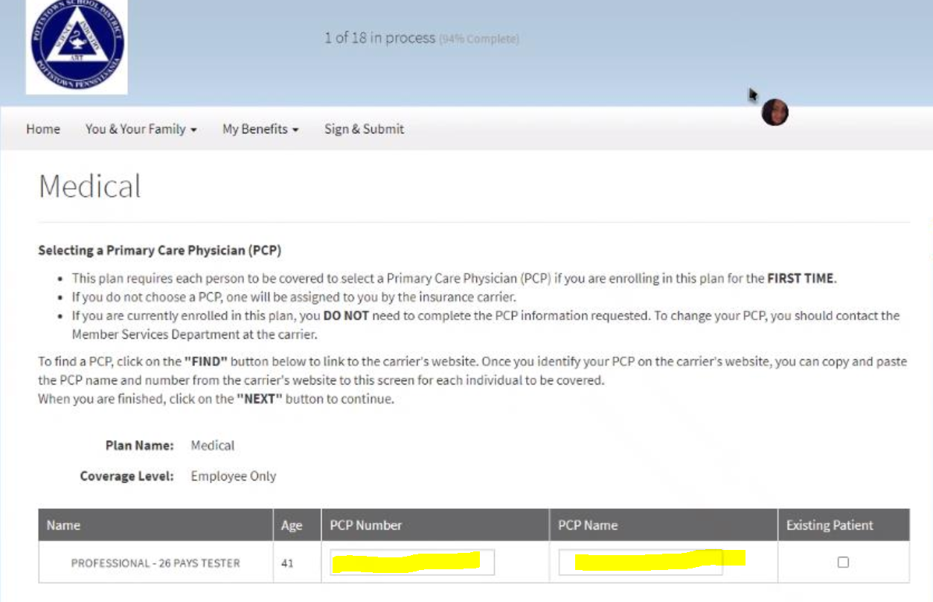

**How you choose or change your PCP**

* Please visit [www.ibx.com/providerfinder](http://www.ibx.com/providerfinder)
* For your location: Use the School district address
* For your plan: Select Keystone/HMO/POS/Direct POS
* For a category: Search by categories to select or change the PCP or click on search

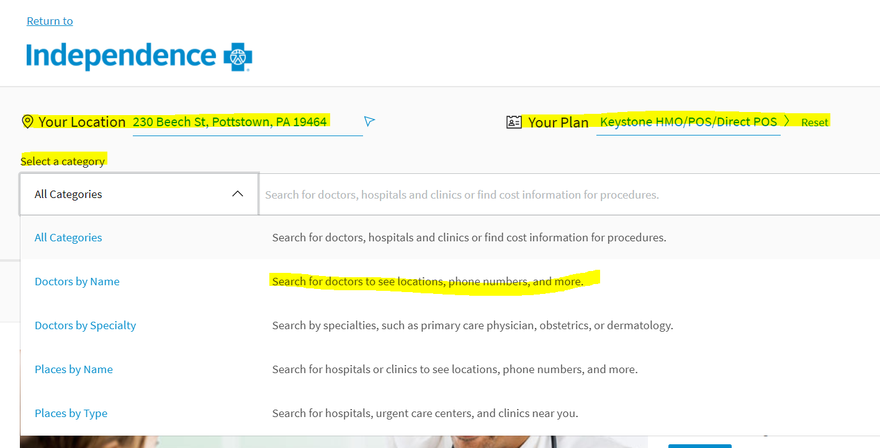

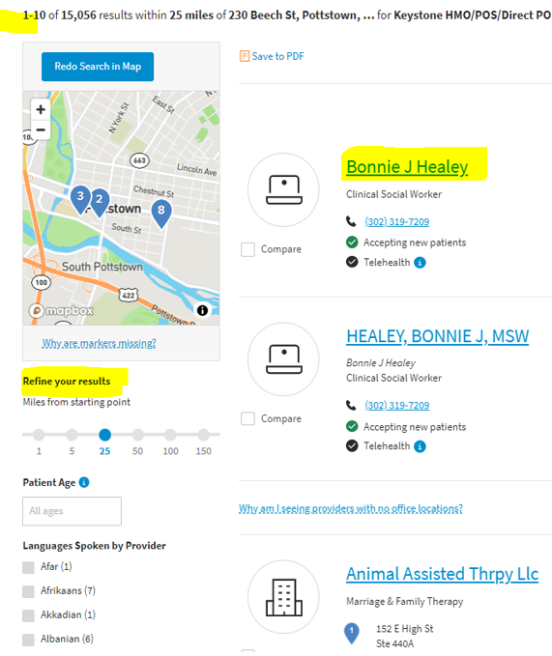If you wish you may refine the search using the column on the left side or click on the name of the PCP.

After selecting the name of the physician, using the cursor, highlight and copy **the PCP name** and **PCP Number YOU CANNOT USE THE NPI# YOU MUST USE THE PROVIDER ID**

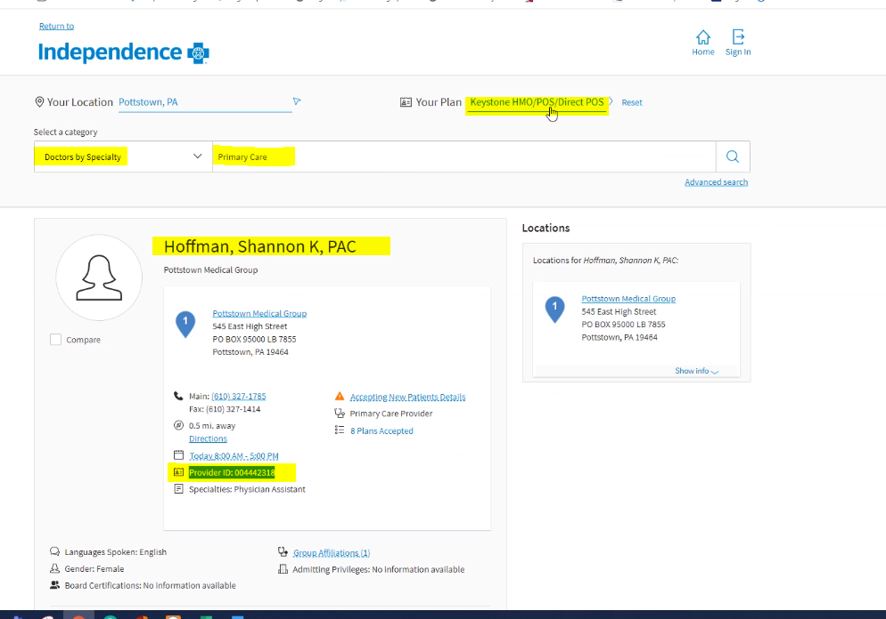

Paste the information in the following enrollment screen (**Selerix**) the **PCP** name and **PCP** number

